For Office Use Only
ST ISSUED
DATE
PAYMENT
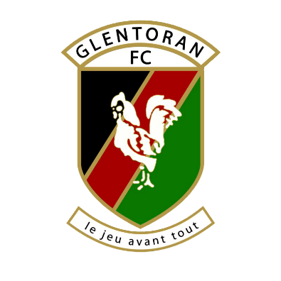
Glentoran
Football
Club
SEASON TICKET APPLICATION FORM 2022-23
For the 22/23 Season FIVE categories of Ticket are available
The Season Ticket will entitle the holder to:
• Admittance to all NIFL Premier League games played at the Oval
• A ticket to any NIFL Premier League home fixture against Linfield FC. Note: This ticket must be collected prior to the game.
Please note: It does NOT entitle entry to the home games in the Irish Cup, League Cup or County Antrim Shield.

Forms MUST be COMPLETED IN FULL before Season Ticket Issued.

PLEASE SELECT TYPE OF TICKET, AREA required
Type | PRICE | Please tick box | Area |  | Please Tick Box
ADULT | £165 |  | GRANDSTAND UPPER
CONCESSION | £90 |  | GRANDSTAND LOWER
YOUTH | £80 |  | TERRACE
CHILD | £10
FAMILY A - 1A/2C | £170
FAMILY B - 1A/2 Y | £315
FAMILY C - 1A/1C / 1Y | £245

NAME:
ADDRESS (inc postcode | Postcode:
DOB (Conc / Child)
TELEPHONE No: | Mobile: Landline:
EMAIL:
SIGNATURE:
By ticking this box you agree to your email being stored by Glentoran Football Club for newsletter and communication purposes.

